Project Documentation

- Project Title : SCRIPT-CONTROLLED ACCESS CONTROL LIST (ACL)
- Team ID : SWTID-2026-9926
- Team Leader : MYTHILI A
Leader Mail ID : 202400534@sigc.edu
- Team Members :
- NIGILESHWARI P - 202400789@sigc.edu
- SUBATHRA S - 202400791@sigc.edu
- POOSHITHA R - 202400913@sigc.edu

2. Abstract
The project demonstrates a basic ServiceNow application configuration workflow. Users and roles are first managed through the administrative interface. A custom Institution Details table is then created to store institution and student information. The table is configured with appropriate fields and records. Finally, an Access Control condition is configured using the Branch field. The screenshots throughout this report provide visual evidence of the steps shown in the supplied video.
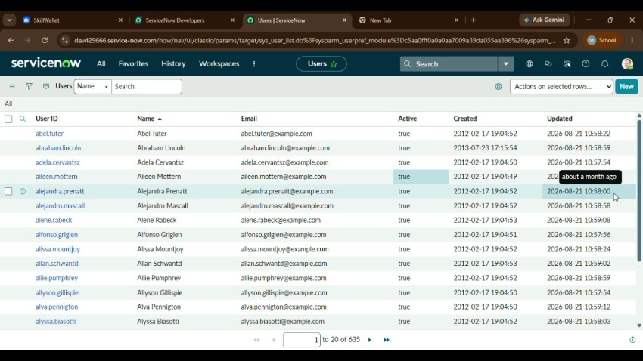

Initial ServiceNow project Screen

3. INTRODUCTION
ServiceNow provides a platform for building enterprise applications using configurable tables, forms, users, roles, workflows and security rules. The project shown in the video uses these features to create a simple information-management structure for institution and student details.

1.1 Objectives
- Understand the ServiceNow administration interface.
- Create and maintain ServiceNow users.
- Configure role membership.
- Create a custom Institution Details table.
- Define fields and maintain table records.
- Configure access control using a branch-based condition.

1.2 Project Scope
The scope covers the configuration activities visible in the supplied demonstration. It is a foundation for a larger application and can later be extended with workflows, notifications, reports and dashboards.

1.3 System Components
Component | Purpose
Users | Stores user identity and contact information
Roles | Controls membership and permissions
Institution Details | Stores institution/student data
Columns | Defines the structure of the table
Access Control | Controls data/operation access

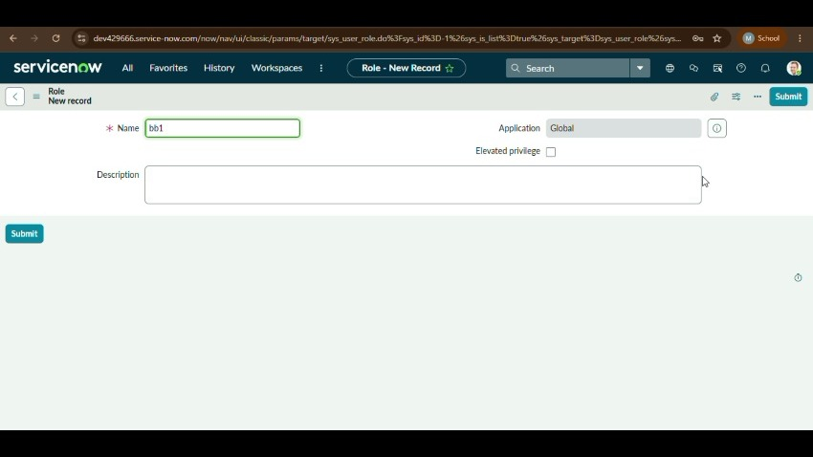
User administration screen
4. USER ADMINISTRATION
The first major stage is user administration. ServiceNow user records contain identity, contact and account information. The administrator can create a new record and maintain the account through the user form.

2.1 Procedure for Creating a User
- Open the Application Navigator.
- Navigate to User Administration → Users.
- Select New.
- Enter User ID, first name and last name.
- Enter title, department and contact details where required.
- Configure Active and Identity Type options.
- Save or submit the user record.
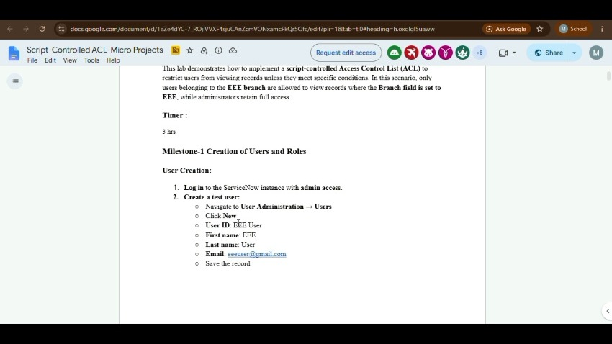
New user record
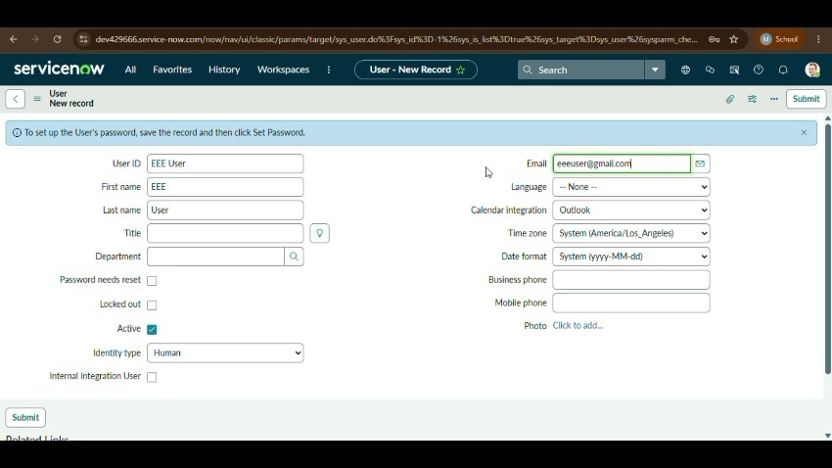
ServiceNow user record details
5. ROLE MANAGEMENT
Roles are used to group permissions and control what users can do in ServiceNow. The demonstration shows opening a role and managing its members.

3.1 Role Membership Steps
- Open the required role from the role administration area.
- Choose Edit Members.
- Search for the required user.
- Add the user to the role.
- Save the membership configuration.

3.2 Importance of Roles
Role-based administration helps separate responsibilities between different users. A role can be assigned to one or more users, and a user can have multiple roles depending on the application requirements.
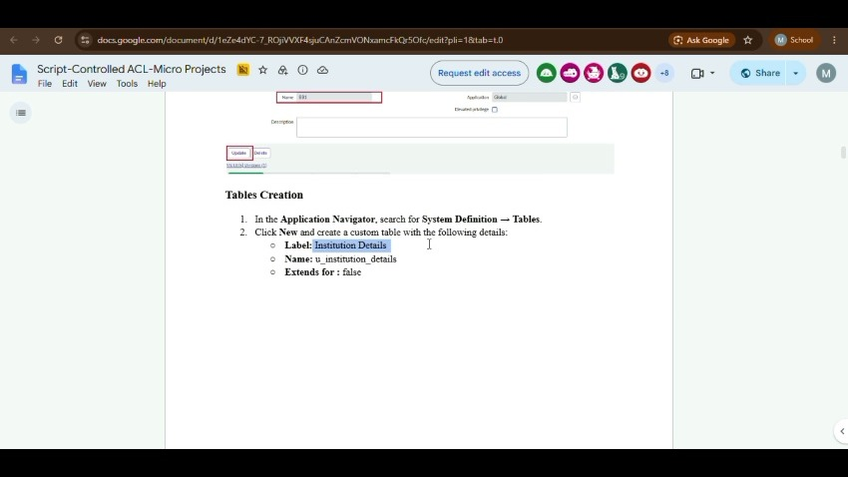
Role/member configuration

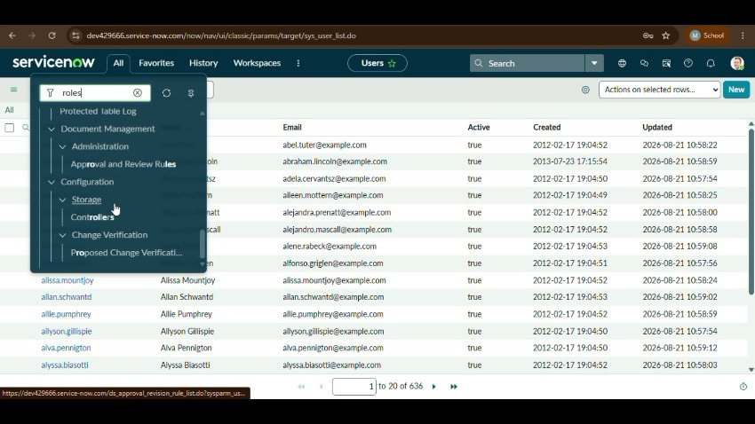
Role configuration
Role member management
6. INSTITUTION DETAILS TABLE
The project creates a custom table named Institution Details. A custom table is used to store project-specific information in a structured form.

4.1 Table Creation Procedure
- Open System Definition → Tables.
- Select New.
- Enter the table label as Institution Details.
- Configure the required options.
- Submit/save the table.
- Open the table and review the Columns section.
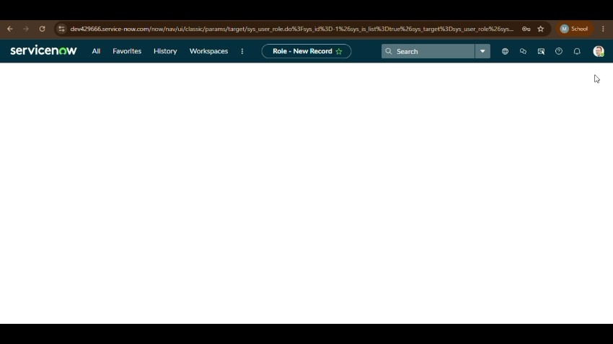
Table configuration
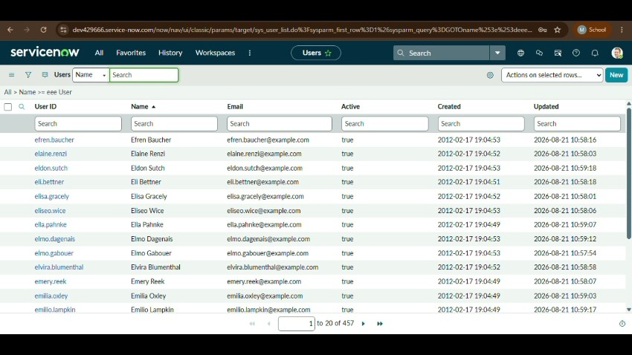
Institution Details table
7. TABLE COLUMNS AND DATA STRUCTURE
The Institution Details table contains fields for storing institution, faculty and student-related data. The exact data type can be selected according to the requirement of the application.

Field | Type | Purpose
Branch | String | Stores the branch/department value
Faculty Name | String | Stores faculty information
Phone Number | String | Stores contact information
Student Name | Reference/User | Identifies the student
Student Roll Number | String | Stores roll number
Email | Email/String | Stores email address
Sys ID | System field | Unique ServiceNow record identifier

5.1 Field Configuration
After the table is created, the Columns section is used to review and configure the fields. This provides the data structure needed for storing and retrieving institution records.
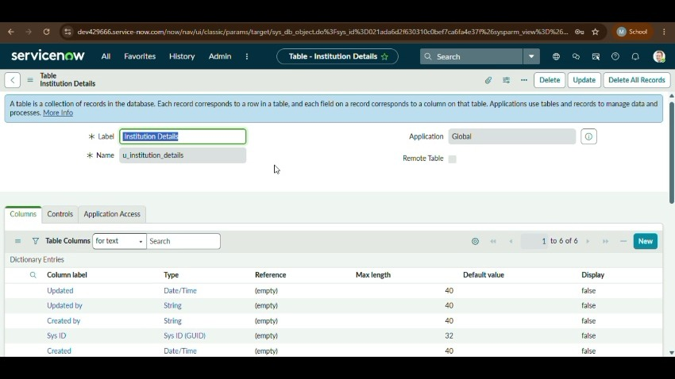
Institution Details table columns
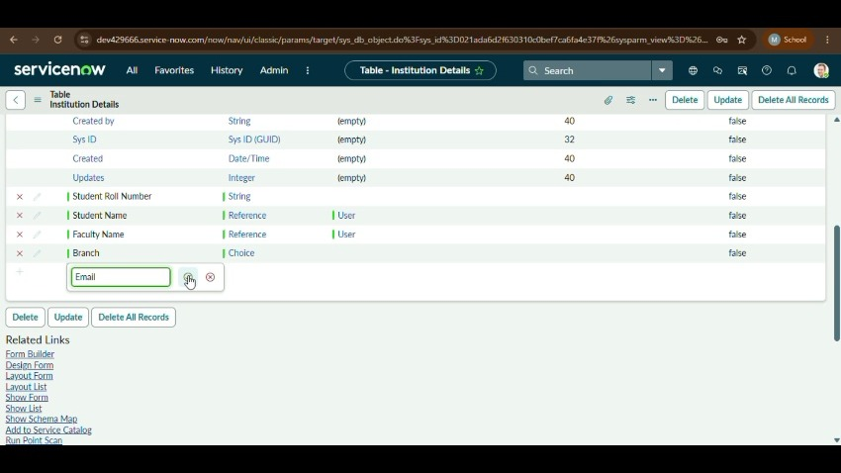
Institution Details field configuration

8. RECORD MANAGEMENT
Once the table and columns are available, records can be entered and displayed through the ServiceNow list and form interfaces. The demonstration shows Institution Details records containing branch and student/faculty information.

6.1 Record Entry Procedure
- Open the Institution Details table.
- Select the option to create a new record.
- Enter branch and faculty information.
- Enter student name, roll number and email.
- Save the record.
- Verify the record in the list view.

6.2 Verification
The list view helps verify that records are stored correctly and that the configured columns appear in the expected order. System fields can also be displayed to identify individual records.
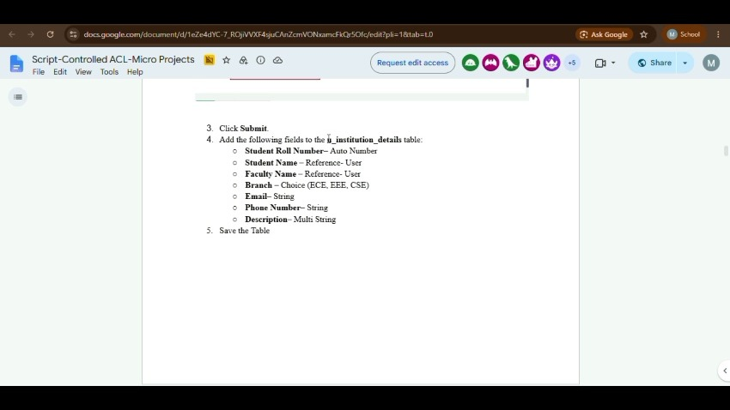
Instructions / table creation screen
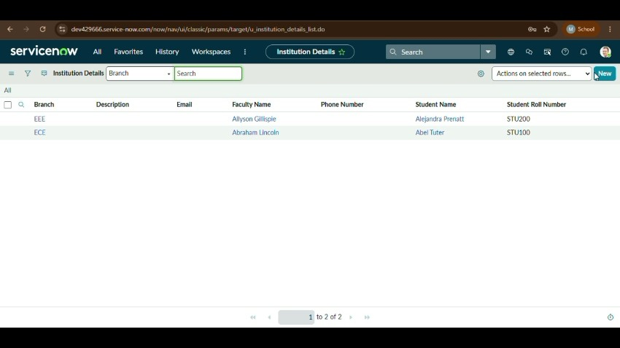
Institution Details records
9. ACCESS CONTROL, TESTING AND CONCLUSION

7.1 Access Control Configuration
The final stage of the video demonstrates an Access Control configuration. A condition is added using the Branch field, with the demonstrated condition set to Branch is EEE.
- Open the Access Control configuration area.
- Create or open the required Access Control record.
- Select the relevant table and operation.
- Add the Branch field as a condition.
- Set the condition to Branch is EEE.
- Save/submit the Access Control record.
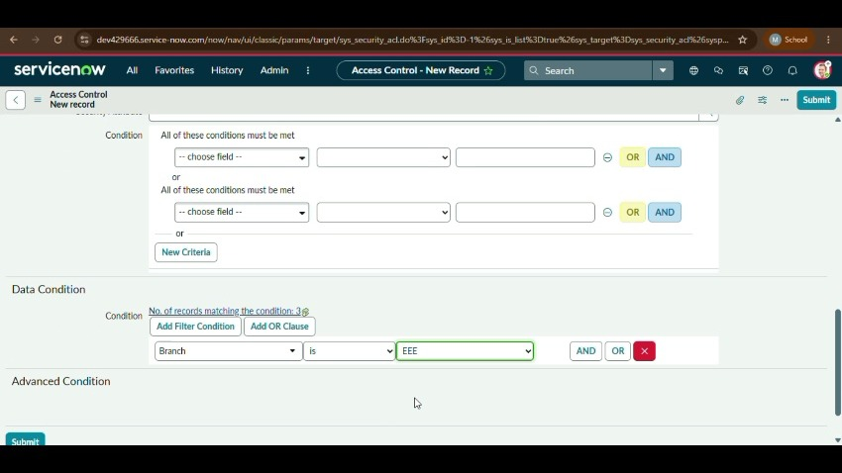
Access Control condition

7.2 Testing Checklist
- User record created successfully.
- Required role membership is visible.
- Institution Details table is available.
- Required columns are displayed.
- Records can be created and verified.
- Access Control condition is saved correctly.

7.3 Result
The demonstrated configuration establishes users and roles, an Institution Details custom table with configured fields and records, and a branch-based Access Control condition.

7.4 Conclusion
The project provides a practical introduction to ServiceNow configuration. It demonstrates the relationship between user administration, role management, data modelling, record management and access control. The resulting configuration can be extended with workflows, notifications, reports and dashboards.

7.5 Future Enhancement
Future work can include automated workflows, validation rules, branch-specific roles, notifications, dashboards, reports and additional Access Control rules.
Source: User-supplied ServiceNow screen-recording video.

Reference :

- Demo Video : https://drive.google.com/file/d/1HoAUHhejD-3IIGf_2CK3TsLTqECL8oo0/view?usp=drivesdk
- Github Link : https://github.com/Mythili534/

